**EXP 14)** Create a Snapshot of a VM and Test it by loading the Previous Version/Cloned VM

**PROCEDURE:**

**STEP 1:** install VM ware software

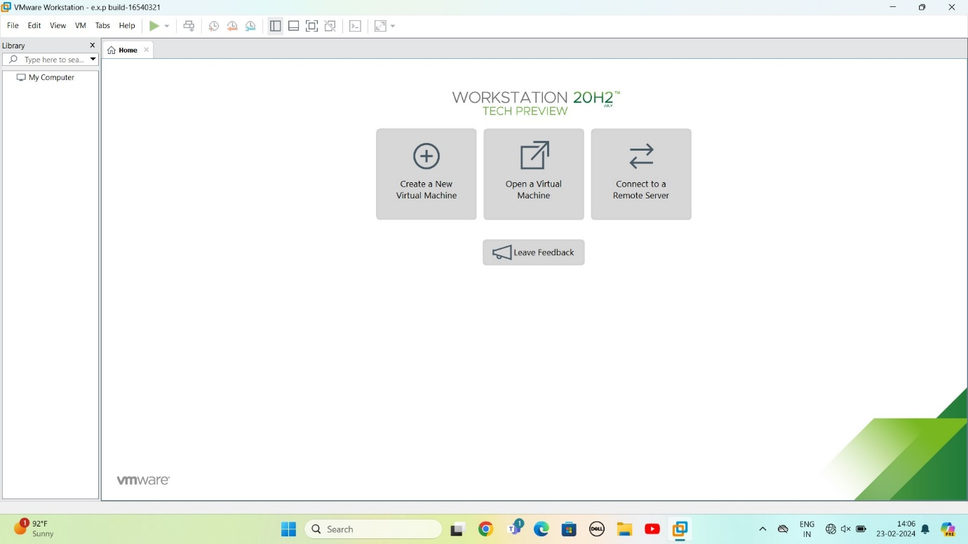

Step 2: CREAT A NEW VIRTUAL MACHINE

GIVE NEXT

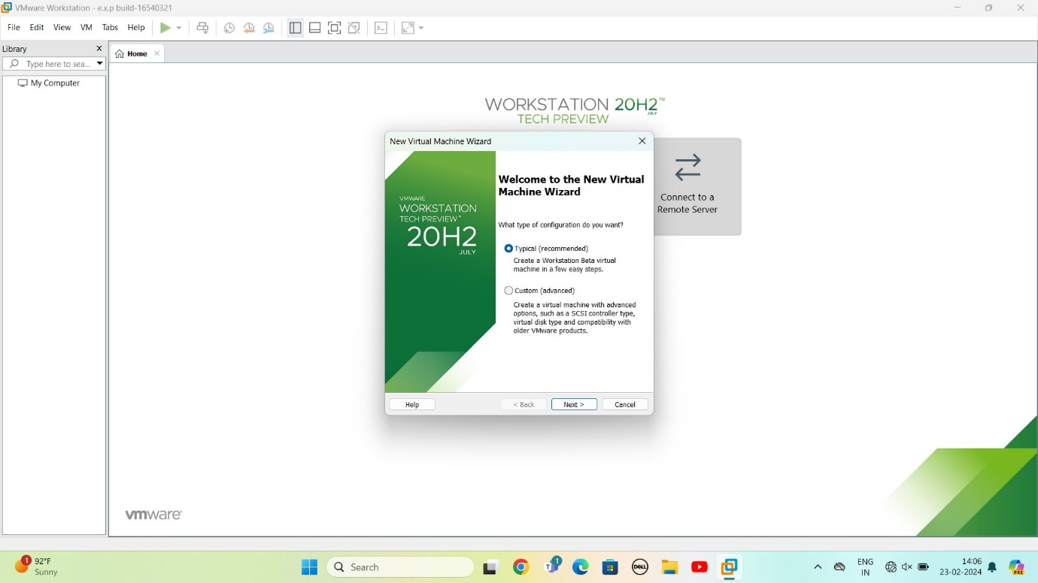

STEP 3: Select I will install operating system later

Give next

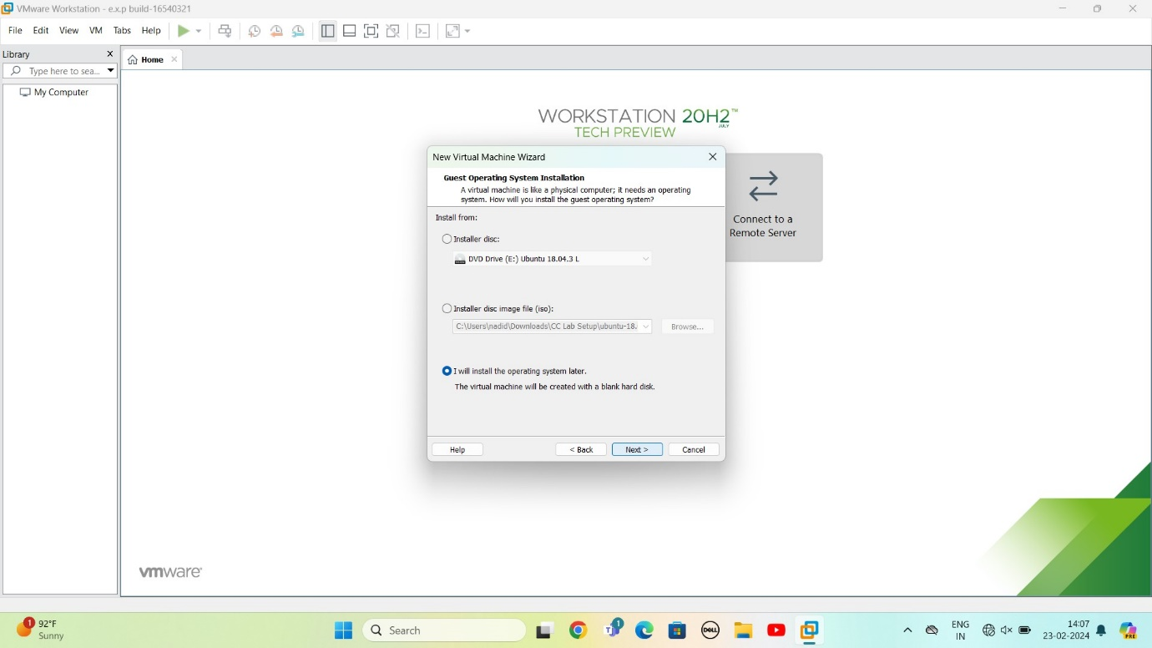

STEP 4: Select gust operating system

Give next

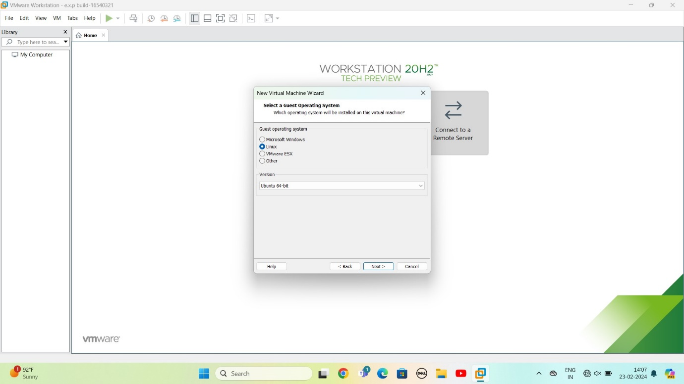

STEP 5: select name of virtual machine

Give next

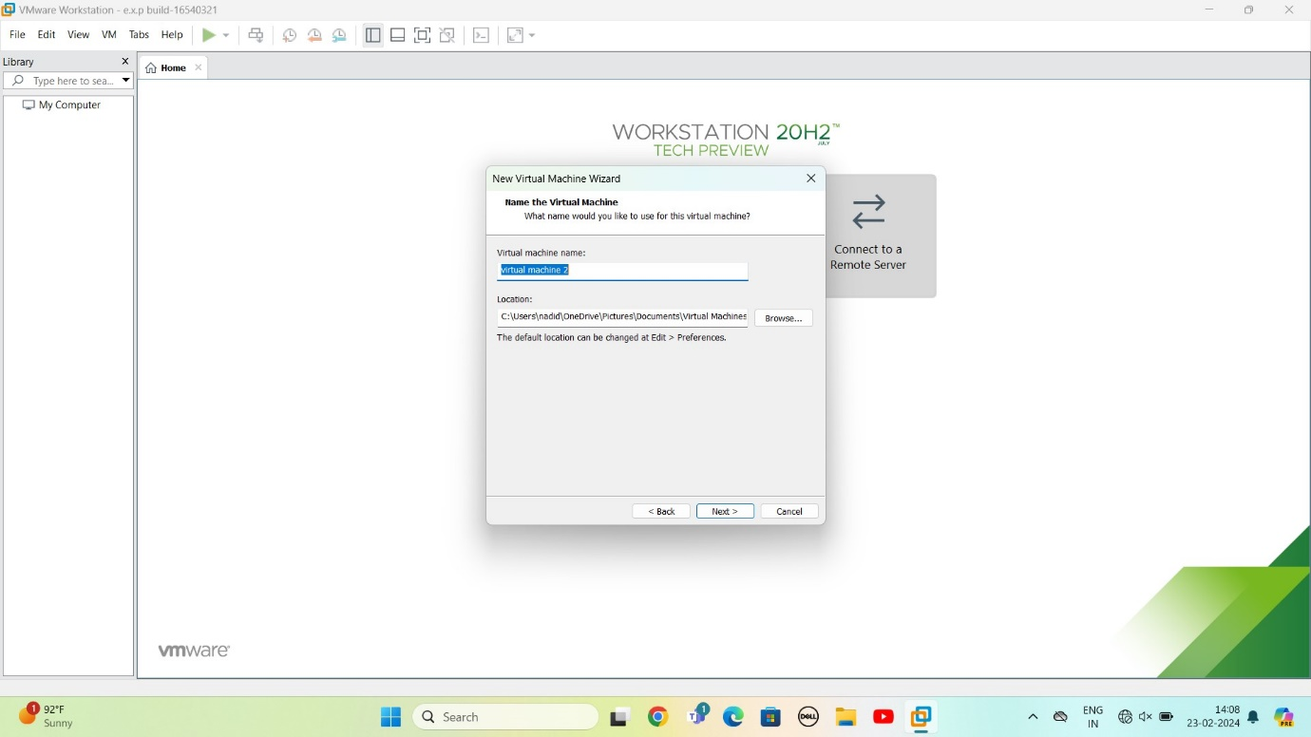

STEP 6: select the data storing disk and maximum size of disk

Give next

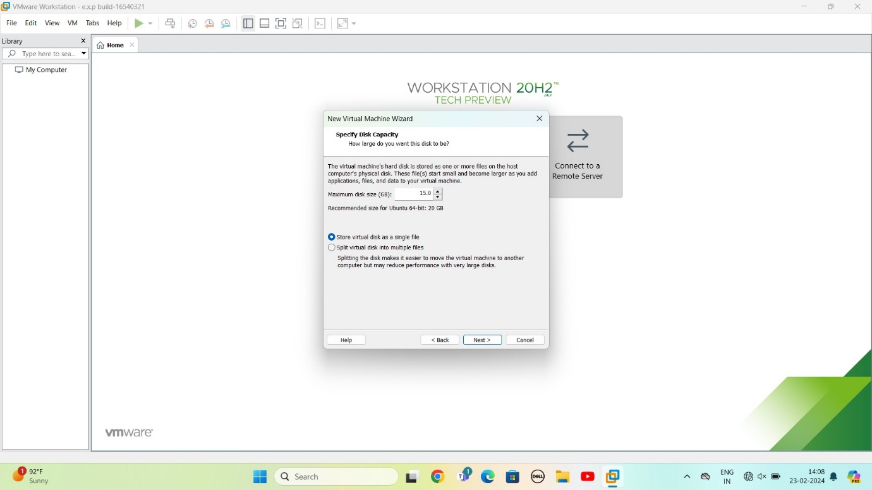

STEP 7: Ready to create virtual machine

Give finish

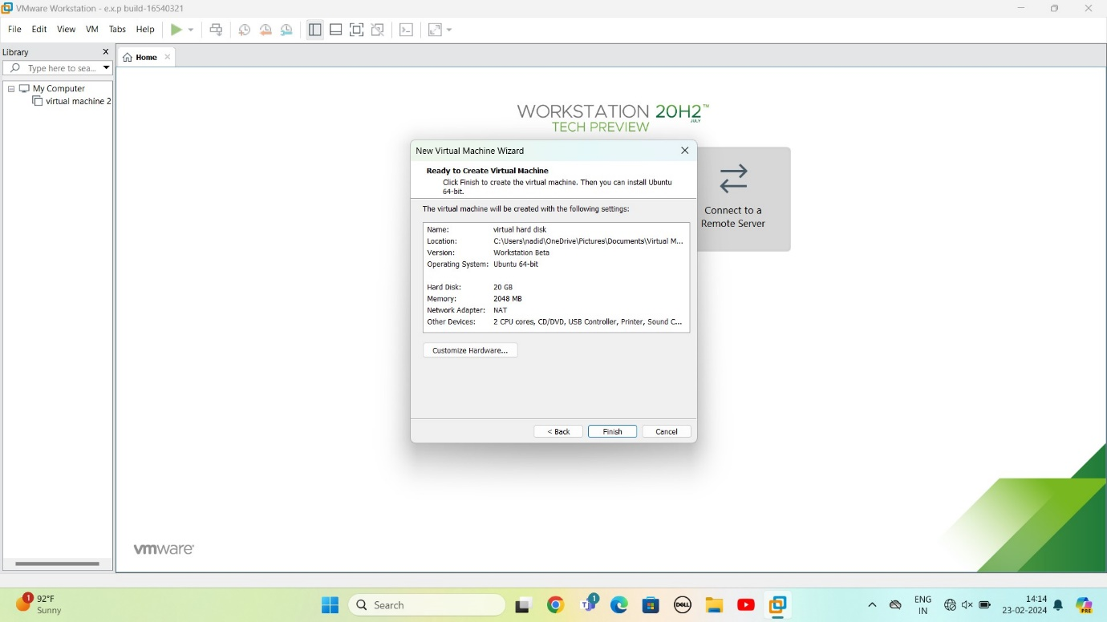

STEP 8: created the virtual machine

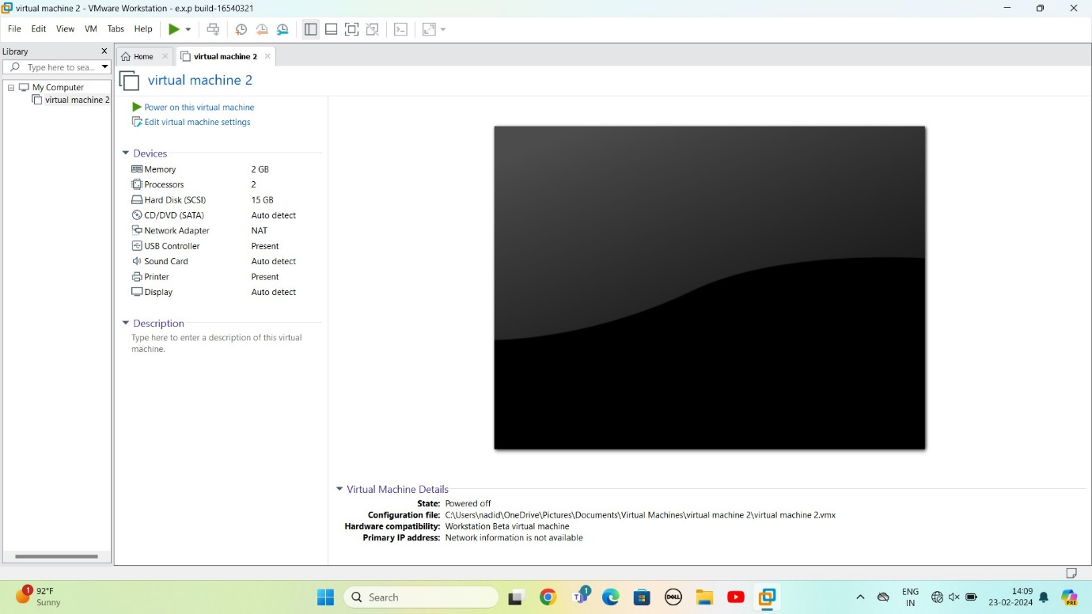

STEP 9: Select VM

Select option snapshot

In that select Take a snapshot

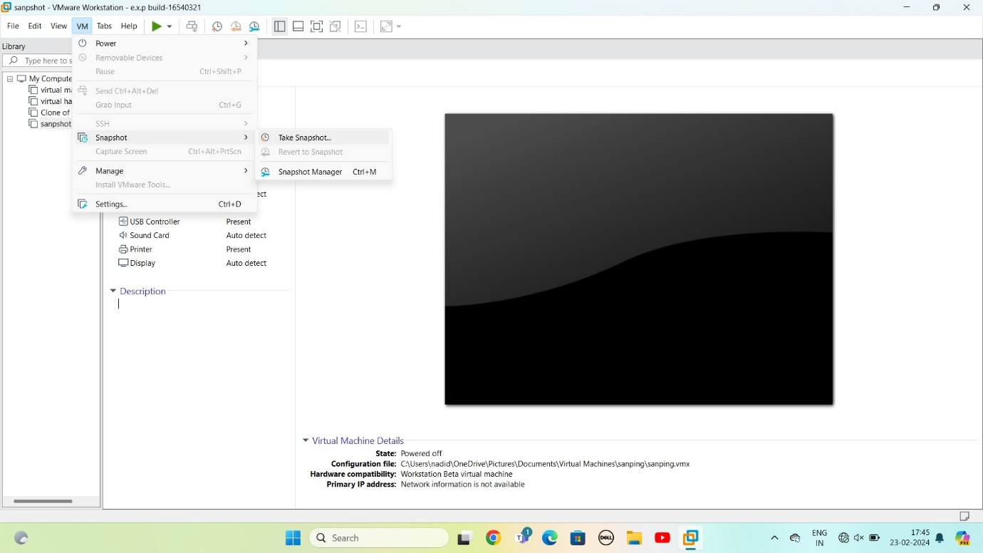

**Step 10:** take Snapshot

Give name as 1

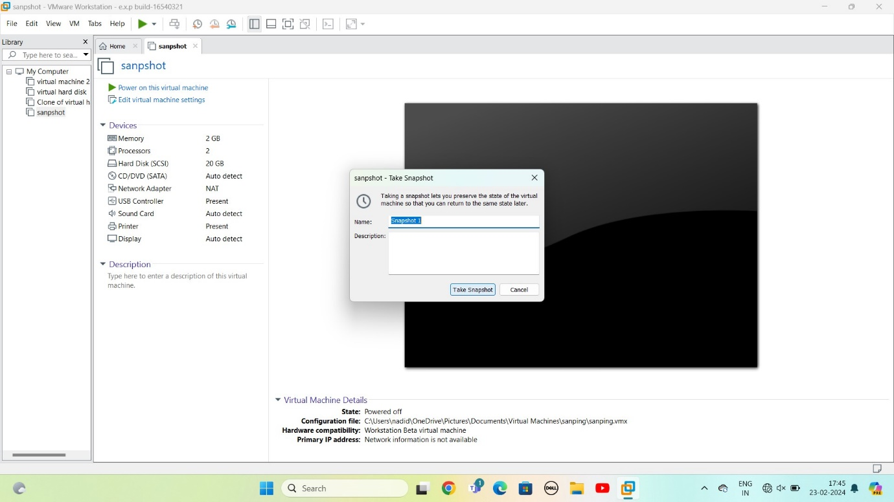

Step 11: change the values memory

Take a snapshot

Give name as Snapshot 2

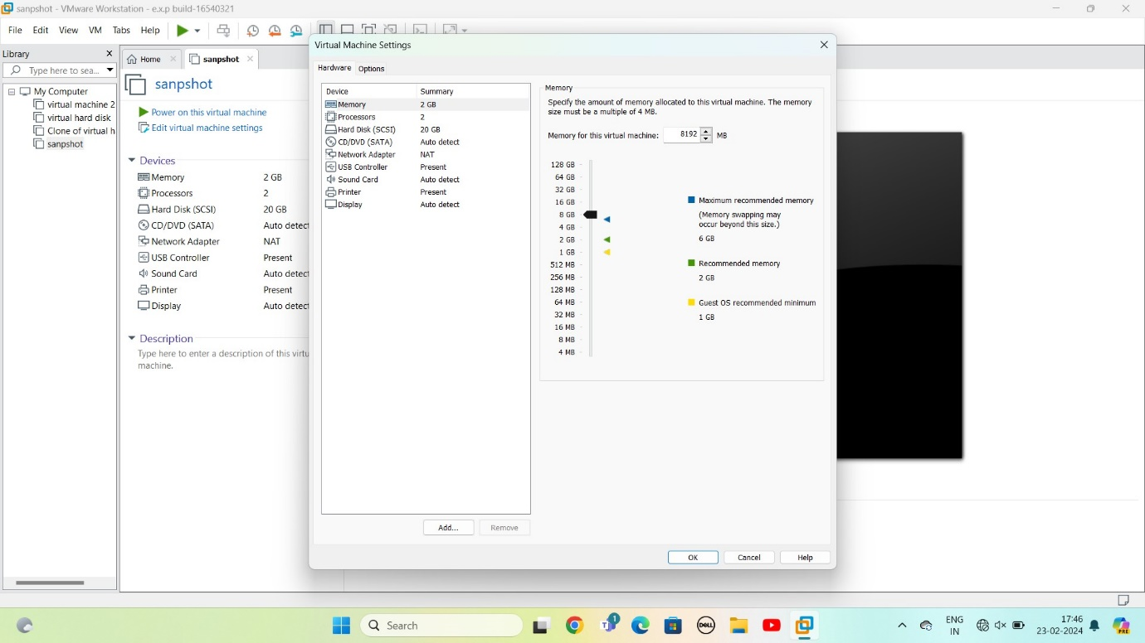

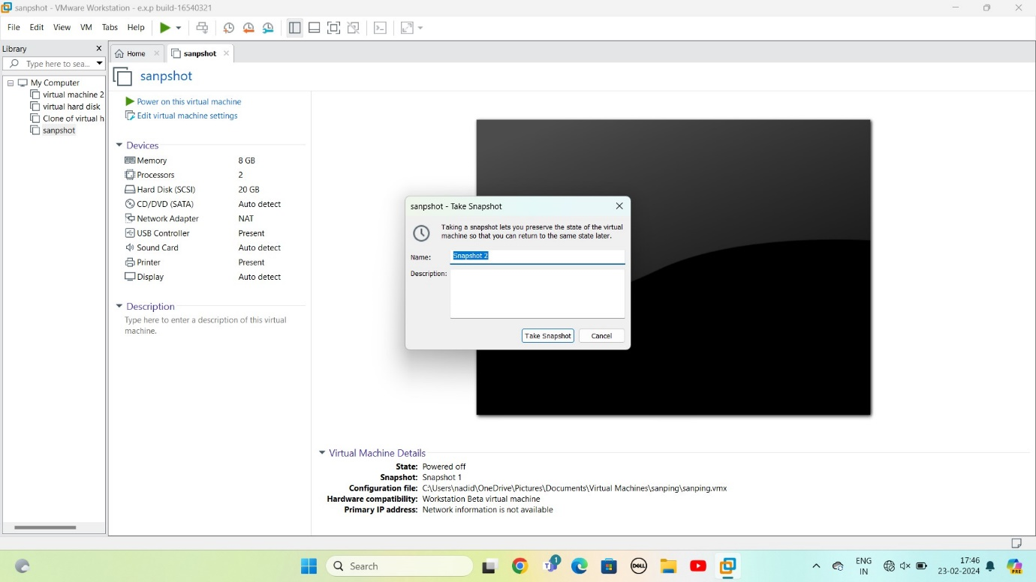

STPE 12: change the values of processor

Take a snapshot

Give name as Snapshot 3

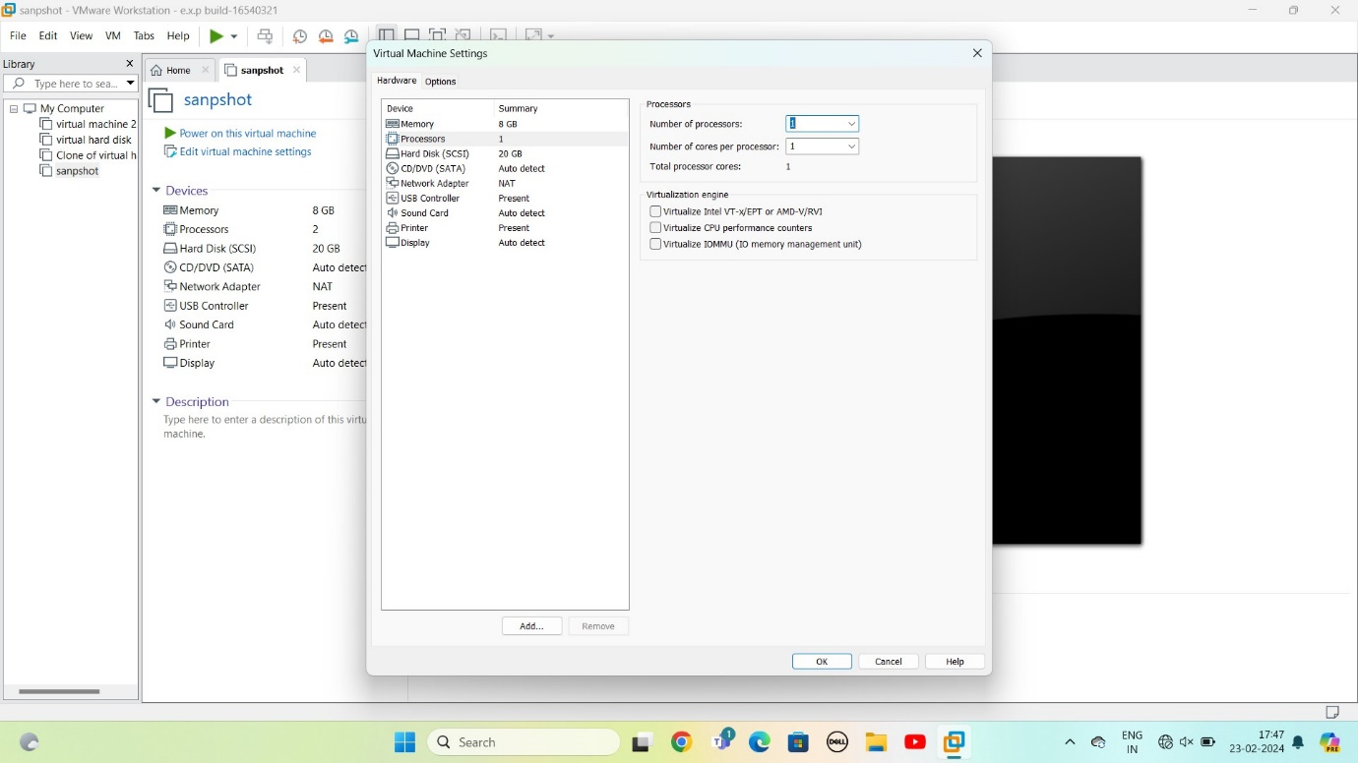

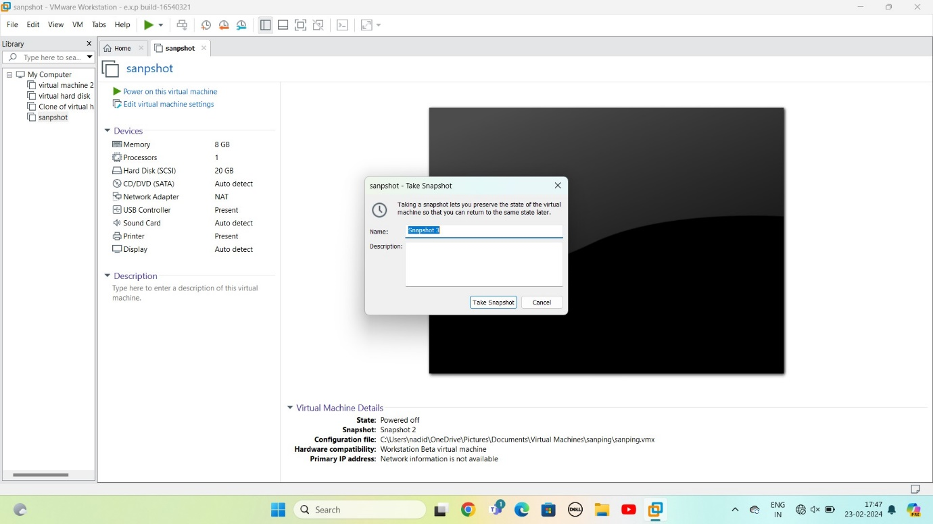

Step 13: GOTO VM

Select option snapshot

In that select snapshot manager

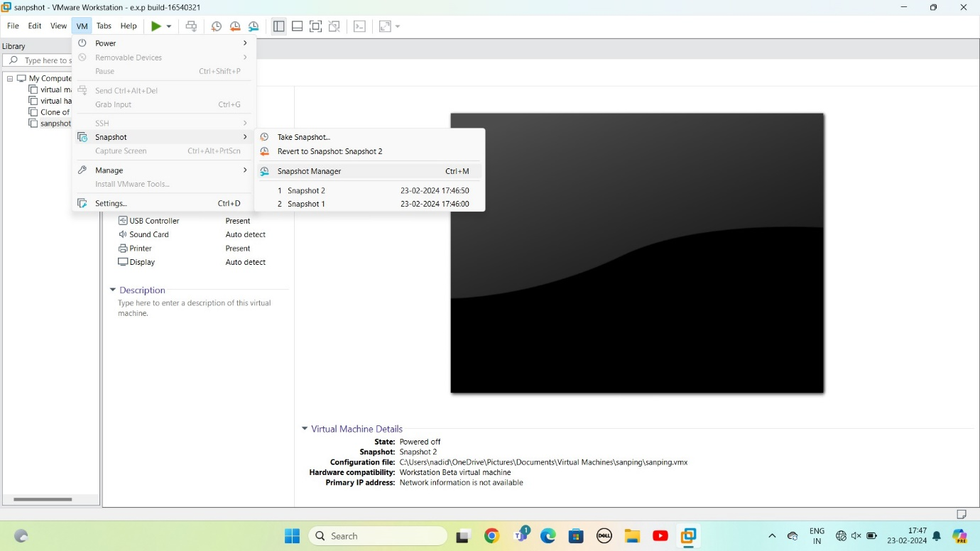

STEP 14: Snapshot manager

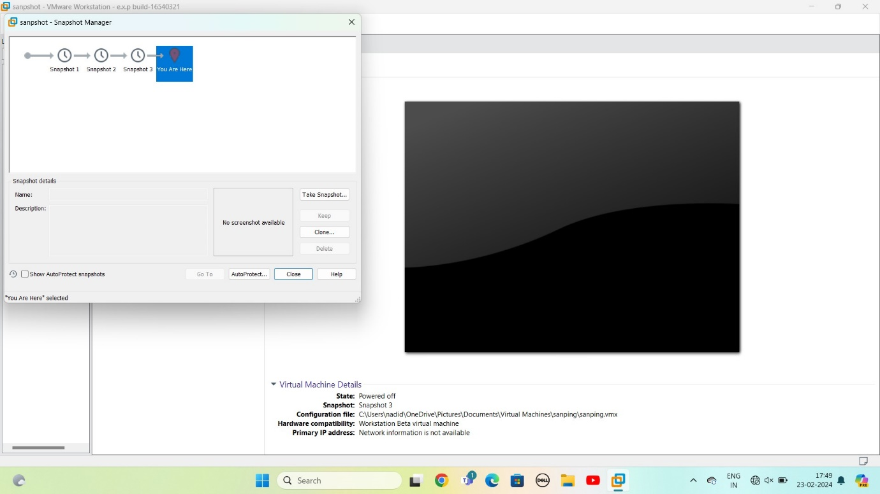

STEP 15: Select any option snapshot 1 or snapshot 2 or snapshot 3

Select GOTO software go that particular snapshot

Click on yes

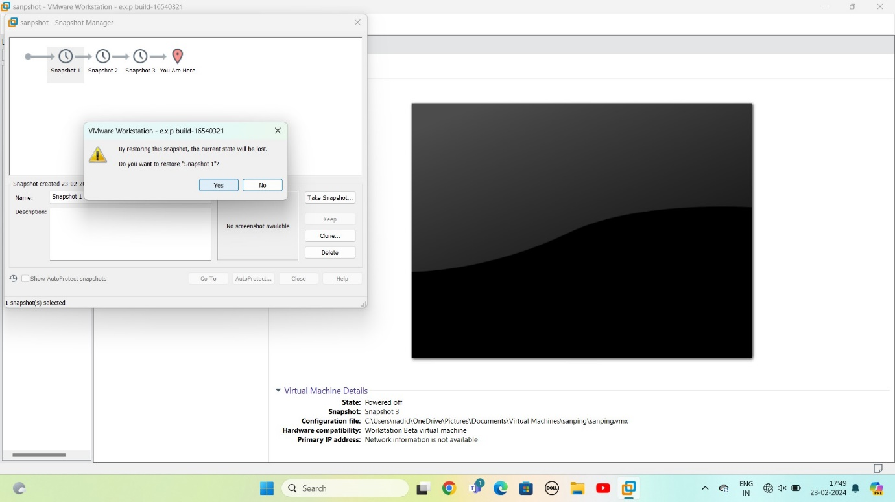

STEP 16: AS PER THE QUESTION GIVEN SOFTWARE IS DEVEPLOED

